~Asia-China-Mirror-Warring States (475-221 BCE)-Arc 8-Bat 4
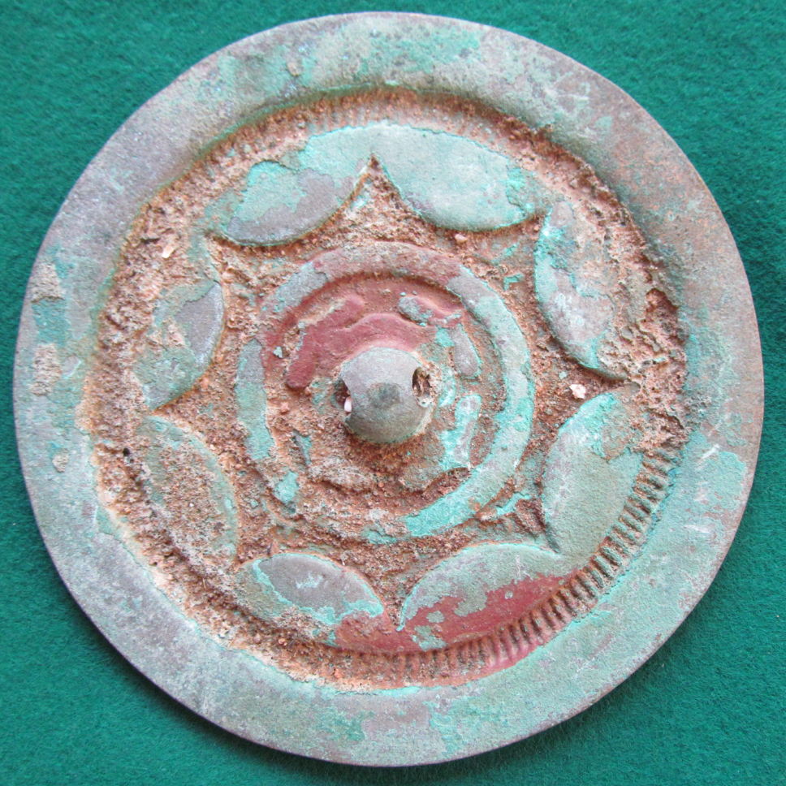
his relatively plain eight continuous arc, 4 bat bronze mirror relfects Warring States simplicity.

